

**What is Shingles?**

Shingles is caused by the same virus as chickenpox, the **varicella zoster virus**, and often presents with a painful rash that is usually on one side of the body.

AGED 70-79?

YOU ARE ELIGIBLE FOR YOUR FREE SHINGLES VACCINE



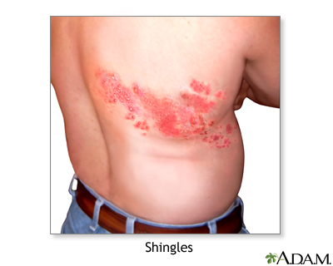

THE VALKYRIE SURGERY

Valkyrie Primary Care Centre

50 Valkyrie Road Westcliff on Sea Essex  
SS0 8BU

***To book your appointment please contact the surgery by telephone during the times specified below, or book quickly and easily via our website.***

www. valkyriesurgery.nhs.uk

Phone: 01702221625/01702221630

BOOKING TIMES:

**Monday 10:00-14:00**

**Tuesday 10:00-14:00**

**Wednesday 10:00-14:00**

**Thursday 10:00-14:00**

**Friday 10:00-14:00**

**Weekend Closed**

**1 in 4** people develop shingles in their lifetime with Incidence and severity increasing with age.

Reduce risk of shingles by **38%** and the likelihood of developing complications such as long-term nerve pain by **67%.** Other complications of shingles include serious chest infections and hearing problems.

**Why Should I get vaccinated?**



FAQs:

* ***I have had shingles, am I still eligible?*** **YES.** Even if you have had shingles, you should still have the vaccine to help prevent future shingles attacks.
* ***I haven’t had chicken pox; do I still need the vaccine****?* **YES.** Even if you have never had chicken pox you should still have the shingles vaccine as it is likely you have come into contact with the virus without knowing.
* ***Where is the vaccine administered?*** Usually in your upper arm, similar to the Flu vaccine.
* ***Does the vaccine cause side effects?*** Side effects are usually mild and last a few days. Common side effects include Fever, headache and fatigue.

For more information about the shingles vaccine and types offered please see below websites or contact your local NHS service provider.

https://www.nhs.uk/conditions/vaccinations/who-can-have-the-shingles-vaccine/

https://www.shinglesaware.co.uk